STATISTICAL ANALYSIS PLAN TEMPLATE
Can be used as template with observational study protocols for

Cohort event monitoring (CEM) study of adverse events following immunization after vaccination with MPOX vaccines

Acknowledgements
The development of this plan was a collaborative effort led by PATH and included contributions from the National Pharmacovigilance Centre (CNPV) of the Democratic Republic of Congo (DRC), within the Unit of Clinical Pharmacology and Pharmacovigilance at the University of Kinshasa, the Africa Centres for Disease Control and Prevention, World Health Organization-AFRO, and the Safety Platform for Emergency Vaccines (SPEAC).

Statistical Analysis Plan for “Cohort event monitoring (CEM) study of adverse events following immunization after vaccination with MPOX vaccines in [COUNTRY]”

Study Design: Active Mpox vaccine safety surveillance will be conducted through an observational prospective single-arm longitudinal study in selected vaccination centers in [COUNTRY].
Objectives: The overall aim of this observational cohort study is to monitor the safety of Mpox vaccines in a cohort of subjects in [COUNTRY] to detect safety signals as soon as the vaccine is used in the ongoing outbreak.
Primary objectives:
- To estimate the incidence of serious adverse events (SAEs) in all enrolled vaccinated individuals after each MPOX vaccine dose, by MPOX vaccine brand.
- To estimate the local and systemic reactogenicity and other common AEFIs occurring within 14 days following each mpox vaccine dose within a subset of participants (‘reactogenicity subset’), by mpox vaccine brand.
Secondary objectives
- To estimate the incidence of adverse events of special interest (AESIs) that result in hospitalization in all enrolled vaccinated individuals after each Mpox vaccine dose, by Mpox vaccine brand.
- Characterize and estimate the incidence of maternal, perinatal and outcomes in women intentionally and inadvertently exposed to mpox vaccine during pregnancy and exposure in the breastfed neonate/infant.
- Characterize and estimate the incidence of AEFIs in immunocompromised individuals and children and adolescents who have been given the mpox vaccine.
- To estimate the incidence of any adverse event, regardless of the severity, after each Mpox vaccine dose, by Mpox vaccine brand.

Analyses:
Interim Analyses:
There will be an interim analysis planned for as soon as possible after 10,000 participants are enrolled, and another after 20,000 participants are enrolled. The tables listed as “Descriptive Statistics” and "Primary Analysis” will be generated at this time. There will also be interim analyses summarizing reactogenicity (Tables 7 and 8) on a quarterly basis.
Calculation of Rates and Proportions:
The analyses described here include estimates of rates and proportions. For the purposes of this SAP, rates will be defined per person-year of follow-up and proportions will be defined as number of participants with the event of interest / number of participants in follow-up at that time relative to vaccination. Thus, participants considered lost to follow-up will be excluded from both calculations at the time when they are determined to be lost.

Descriptive Statistics:
- Table of baseline characteristics of participants (sex, age, health conditions, and type of medications) by site. For categorical variables (e.g. sex, health conditions) the number and percentage of participants in each category will be given. For continuous variables, the median and IQR will be given.

Table 1. Baseline Demographics of Study Participants.
 | Health zone 1  N (%) | Health zone 2  N (%) | Health zone 3  N (%) | Total N (%)
Sex
Female
Male
Type of vaccine administered
MVA-BN
LC16m8
Duration of follow-up
Median (IQR)
≥14 days follow-up
≥28 days follow-up
≥56 days follow-up
Age groups
1-4 years
5-11 years
12-17 years
18-29 years
30-49 years
50-64 years
65+ years
Age median (IQR)
Underlying diseases
No medical history
Diabetes
Chronic heart disease
Chronic respiratory disease or asthma
Chronic liver disease
Chronic renal disease
Immuno-compromised/suppressed
Obesity
Pregnancy & lactation
Pregnant
Lactating
Not pregnant nor lactating

- Table of any adverse events by demographics.
Table 2. Summary of any adverse events in various sex, age groups, underlying diseases and pregnancy & lactation, overall and by vaccine.
 |  | Vaccine Brand
 | MV | A-BN | LC16m8 |  | Total
 | N= | 95% CI | N (%) | 95% CI | N= (%) | 95% CI
Sex
Female
Male
Age groups
1-4 years
5-11 years
12-17 years
18-29 years
30-49 years
50-64 years
65+ years
Median (IQR)
Duration of follow-up
Median (IQR)
≥14 days follow-up
≥28 days follow-up
≥56 days follow-up
Underlying diseases
No medical history
Diabetes
Chronic heart disease
Chronic respiratory disease or asthma
Chronic liver disease
Chronic renal disease
Immuno-compromised/suppressed
Obesity
Pregnancy & lactation
Pregnant*
Lactating*
Not pregnant nor lactating*
* Percentages should be based on number of females, not total n.
Primary Analyses:
- Tables and figures of Serious Adverse Events (SAEs) by vaccine brand (Primary Objective 1).
Table 3. Table of Serious Adverse events, grouped by MedDRA preferred term.
SAE (MedDRA preferred term) |  |  | Vaccine Brand
SAE (MedDRA preferred term) | MVA-BN (N= ) |  | LC16m8 (N= ) |  | Total (N= )
SAE (MedDRA preferred term) | n | 95%CI | n | 95%CI | n | 95%CI
SAE1
SAE2
SAE3
SAE4
SAE5
SAE6

Table 4. Table of Serious Adverse Events (SAEs), grouped by system organ class.
SAE (system organ class) |  |  | Vaccine Brand
SAE (system organ class) | MVA-BN (N= ) |  | LC16m8 (N= ) |  | Total (N= )
SAE (system organ class) | n | 95%CI | n | 95%CI | n | 95%CI
SAE1
SAE2
SAE3
SAE4
SAE5
SAE6

Figure 1. Incidence of SAEs per 1,000 vaccinees.
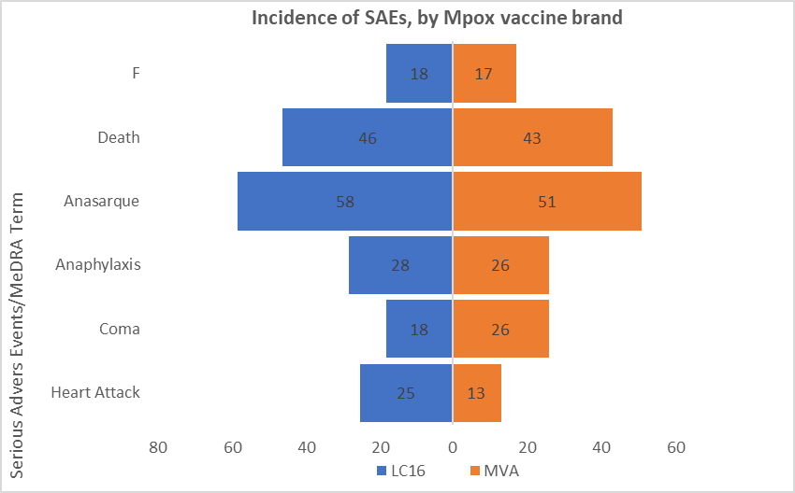

Table 5. Summary of Serious Adverse Events by Seriousness Criteria grouped by Vaccine Brand and dose.
 | MVA-BN (N= ) |  | LC16m8 (N= ) |  | Total
 |  | 95% CI | N= | 95% CI | N= (%) | 95% CI
Hospitalization (initial/prolonged)
Persistent or significant disability/incapacity
Congenital anomaly/birth defect
Medically significant (other)
Figure 2. Onset of SAEs relative to vaccination. X-axis indicates the number of days; Y-axis indicates the proportion of participants reporting SAEs.
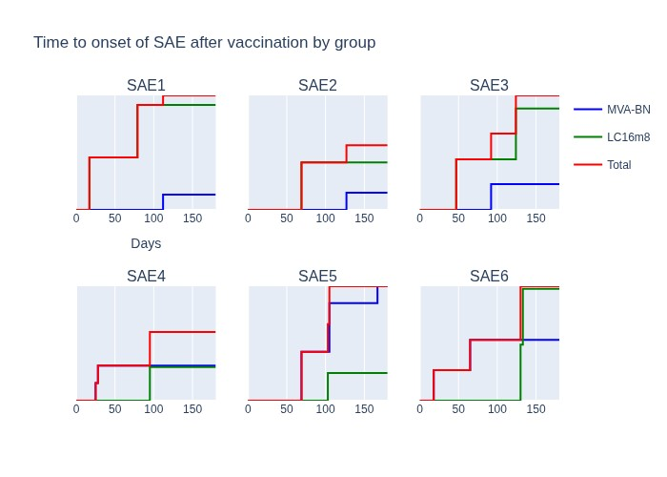
- Analysis of potential predictors for SAEs:
Logistic regression will be used to identify potential risk factors for any SAE in this study. Logistic regression of any SAEs or grade 3 AE by mpox vaccine brand, dose, health zone, sex and age. Results of the logistic regression analysis will be listed in a table represented by the OR with its 95% CI as well as the P-value. Multicollinearity will be assessed between predictor variables using the Variance Inflation Factor (VIF). Confounding and interaction will be assessed. The goodness of model fit will be assessed by the Hosmer Lemeshow goodness of fit test. A p-value < 0.05 will be used to declare statistical significance. R or Stata
IC version 16 (Stata Corp) will be used to perform this analysis. (Primary Objective 1)

If there are sufficient SAEs/AEs to fit the multivariate model, that is what will be presented. If the number of SAEs is not adequate to support a model, then univariate results will be presented.

Table 6. Logistic regression of any SAEs or serious AE by mpox vaccine brand, sex, age category and underlying health status.
Variables (N= ) | Group | Events (n) | % AE | OR (95%CI) | P-value
Sex | Male |  |  | Ref | --
Sex | Female
Type of vaccine administered | MVA-BN |  |  | Ref | --
Type of vaccine administered | LC16m8
Age groups | <18 years |  |  | Ref | --
 | 18-59 years
 | 60+ years
Underlying diseases | No medical history |  |  | Ref | --
Underlying diseases | Diabetes
Underlying diseases | Chronic heart disease
Underlying diseases | Chronic respiratory disease or asthma
Underlying diseases | Chronic liver disease
Underlying diseases | Chronic renal disease
Underlying diseases | Obesity
Pregnancy | Non-pregnant |  |  | Ref | --
Pregnancy | Pregnant
Lactation | Non-lactating |  |  | Ref | --
Lactation | Lactating
Immune system | Not immunocompromised |  |  | Ref | --
Immune system | Immunocompromised

- Local and Systemic reactions and other common AEFIs:
Tables and Figures of local and systemic reactogenicity and other common AEFIs occurring within 14 days following each mpox vaccine dose within a subset of participants (‘reactogenicity subset’), by severity score, mpox vaccine brand and dose. The number and percentage of participants in each category will be given, with an exact 95% confidence interval. (Primary Objective 2).
Table 7. Local Reactions within 14 days by Vaccine brand among participants in the “Reactogenicity Subset.”
Local reactions | Vaccine Brand |  |  |  | Total (N=_)
Local reactions | MVA-BN (N= ) |  | LC16m8 (N= )
Local reactions | n | 95%CI | n | 95%CI | n | 95%CI
Induration/swelling
Injection site pain
Bruise/redness
Itching

Table 8. Systemic Reactions and other AEFIs within 14 days by Vaccine brand among participants in the “Reactogenicity Subset.”
Systemic reactions |  |  | Vaccine brand
Systemic reactions | MVA-BN (N= ) |  | LC16m8 (N= ) |  |  | Total (N=)
Systemic reactions | n | 95%CI | n | 95%CI | n | 95%CI
Fever
Myalgia
Headache
Diarrhea

Secondary Analyses:
- Adverse Events of Special Interest (AESI) that result in hospitalization by vaccine brand and dose. The number and percentage of participants in each category will be given, with an exact 95% confidence interval (Secondary Objective 1).
Table 9. Adverse events of Special Interest grouped by vaccine brand and dose.
 |  |  | Vaccine Brand
 | MVA-BN (N= ) |  | LC16m8 (N= ) |  |  | Total (N=)
 | n (%) | 95% CI | n (%) | 95% CI | n (%) | 95% CI
AESI1
AESI2
AESI3

- Maternal, Perinatal and birth outcomes among women exposed to mpox vaccine during pregnancy.
Table 10. maternal, perinatal and infant outcomes among women who received mpox vaccination while pregnant.
Maternal and Infant Outcomes: | Vaccination Timing: |  |  | Vaccine Brand
Maternal and Infant Outcomes: | Vaccination Timing: | MVA-BN (N= ) |  | LC16m8 (N= ) |  | Total (N=)
Maternal and Infant Outcomes: | Vaccination Timing: | N(%) | 95%CI | n (%) | 95%CI | n (%) | 95%CI
Full term, live birth | 1st trimester:  2nd trimester  3rd trimester:
Fetal Loss 1st trimester  (weeks 1-12) | 1st trimester:
Fetal Loss 2nd trimester  (weeks 13-27) | 1st trimester:
Fetal Loss 2nd trimester  (weeks 13-27) | 2nd trimester:
Fetal Loss 3rd trimester  (weeks 28-40) | 1st trimester:  2nd trimester  3rd trimester:
Other (specify)

Table 11. maternal, perinatal and infant outcomes among women who received mpox vaccination while pregnant: timing of outcomes.
Maternal and Infant Outcomes: | Vaccination Timing: |  |  | Vaccine Brand
Maternal and Infant Outcomes: | Vaccination Timing: | MVA-BN (N= ) |  | LC16m8 (N=) |  | Total (N= )
Maternal and Infant Outcomes: | Vaccination Timing: | Mean | Min, Max | Mean | Min, Max | Mean | Min, Max
Full term, live birth | 1st trimester:  2nd trimester  3rd trimester:
Fetal Loss 1st trimester  (weeks 1-12) | 1st trimester:
Fetal Loss 2nd trimester  (weeks 13-27) | 1st trimester:
Fetal Loss 2nd trimester  (weeks 13-27) | 2nd trimester:
Fetal Loss 3rd trimester  (weeks 28-40) | 1st trimester:  2nd trimester  3rd trimester:

- AEFIs in vaccinated immunocompromised individuals and children and adolescents.
Table 12a. AEFI among immunocompromised individuals, by vaccine brand.
AEFIs in immunecompromised  individuals |  |  | Vaccine Brand
AEFIs in immunecompromised  individuals | MVA-BN (N= ) |  | LC16m8 (N= ) |  | Total (N=)
AEFIs in immunecompromised  individuals | n (%) | 95%CI | n (%) | 95%CI | n (%) | 95%CI
AEFI1
AEFI2
AEFI3
AEFI4
AEFI5
AEFI6

Table 12b. AEFI among children and adolescents (<19 years), by vaccine brand.
AEFIs in children and adolescents (<19 Years) |  |  | Vaccine brand
AEFIs in children and adolescents (<19 Years) | MVA-BN (N= ) |  | LC16m8 (N= ) |  | Total (N=)
AEFIs in children and adolescents (<19 Years) | n (%) | 95%CI | n (%) | 95%CI | n (%) | 95%CI
AEFI1
AEFI2
AEFI3
AEFI4
AEFI5
AEFI6

- Adverse Events, regardless of severity, after mpox vaccination by brand.
Table 13a: Among those who received MVA-BN.
AE  (MedDRA preferred term). | Severity score |  |  | Sex |  | Age group, N (%: 95CI)
AE  (MedDRA preferred term). | Grade 1 N (%:  95CI) | Grade 2 N (%:  95CI) | Grade 3 N (%:  95CI) | Male  N  (%:95CI) | Female N (%:  95CI) | <18 years, N (%:  95CI) | 18-59 years, N (%:  95CI) | 60 years and +, N (%:  95CI)
AE1
AE2
AE3
AE4
AE5
AE6

Table 13b: Among those who received LC16m8.
AE  (MedDRA preferred term). | Severity score |  |  | Sex |  | Age group n (%: 95CI)
AE  (MedDRA preferred term). | Grade 1 N (%:  95CI) | Grade 2 N (%:  95CI) | Grade 3 N (%:  95CI) | Male N (%:  95CI) | Female N (%:  95CI) | <18  years, N (%:  95CI) | 18-59 years, N (%:  95CI) | 60 years and +, N (%:  95CI)
AE1
AE2
AE3
AE4
AE5
AE6

Exploratory and Supplementary Analyses.
Figure 3. Types of reactions and duration of their persistence. X-axis indicates the number of days; Yaxis indicates the proportion of participants reporting reactions persisting from day 1 to 10. The graph on the left represents events among participants who received MVA-BN; the graph on the right represents events among participants who received LC16m8.
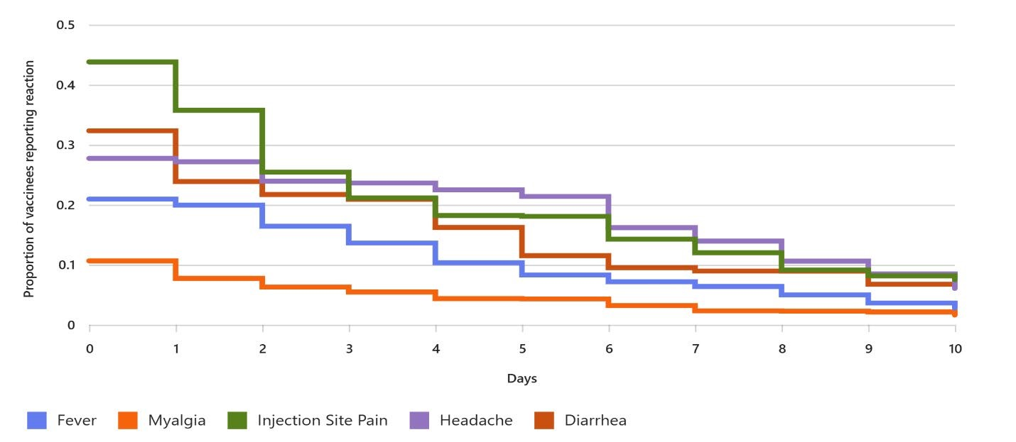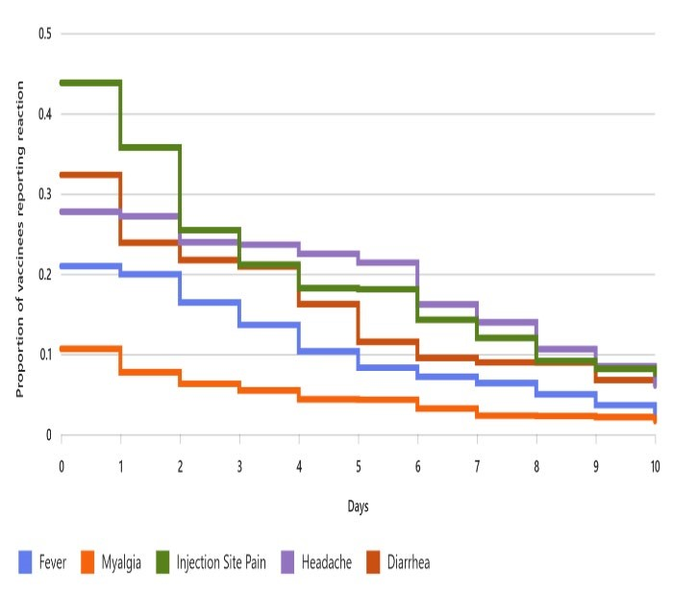

Univariate logistic regression of specific AE/SAEs:
For the frequently observed Preferred Term (PT) AEs or SAEs that have sufficient cases to allow further analysis (at least 10 cases), univariate exact logistic regression models will be explored for prediction of that specific PT events. Models should be fit to predict the specific PT events using predictor variables sex, type of vaccine, age group, underlying disease, pregnant and/or lactating, and immunocompromised. Tables summarizing these univariate models will be included in the statistical report in an appendix. Table 14 below gives a structure for these tables and should be repeated for up to ten PT AE/SAE that has at least 10 observed cases.

Table 14a: Results of univariate exact logistic regressions of << Name of AE/SAE #1>>
Variables (N= ) | Group | Events (n) | % AE | OR  (95%CI) | P-value
Type of vaccine administered | MVA-BN |  |  | Ref | --
Type of vaccine administered | LC16m8
Sex | Male |  |  | Ref | --
Sex | Female
Age groups | <18 years |  |  | Ref | --
Age groups | 18–59 years
Age groups | 60+ years
Underlying diseases* | No medical history |  |  | Ref | --
Underlying diseases* | Diabetes
Underlying diseases* | Chronic heart disease
 | Chronic respiratory disease or asthma
 | Chronic liver disease
 | Chronic renal disease
 | Obesity
Pregnancy | Non-pregnant |  |  | Ref | --
Pregnancy | Pregnant
Lactation | Non-lactating |  |  | Ref | --
Lactation | Lactating
Immune system | Not immunocompromised |  |  | Ref | --
Immune system | Immuno-compromised
- Underlying diseases may be coded as “none”/”any” if there are concerns that the number of events is too small to fit a stable model

Multivariate logistic regression of specific AE/SAEs:
For any AEs or SAEs that have sufficient cases to allow multivariate analysis (at least 30 cases), multivariate logistic regression models will be explored for prediction of that specific AE/SAE. Models should be fit to predict the specific AE/SAE using predictor variables sex, type of vaccine, age group, underlying disease, pregnant and/or lactating, and immunocompromised. Tables summarizing these multivariate models will be included in the statistical report in an appendix. Table 15 below gives a structure for these tables and should be repeated for each AE/SAE that has at least 30 observed cases.

Table 15: Results of multivariate logistic regressions of << Name of AE/SAE>>
Variables (N= ) | Group | Events (n) | % AE | OR (95%CI) | P-value
Sex | Male |  |  | Ref | --
Sex | Female
Type of vaccine administered | MVA-BN |  |  | Ref | --
Type of vaccine administered | LC16m8
Age groups | <18 years |  |  | Ref | --
Age groups | 18-59 years
Age groups | 60+ years
Underlying diseases* | No medical history |  |  | Ref | --
Underlying diseases* | Diabetes
Underlying diseases* | Chronic heart disease
Underlying diseases* | Chronic respiratory disease or asthma
Underlying diseases* | Chronic liver disease
Underlying diseases* | Chronic renal disease
Underlying diseases* | Obesity
Pregnancy | Non-pregnant |  |  | Ref | --
Pregnancy | Pregnant
Lactation | Non-lactating |  |  | Ref | --
Lactation | Lactating
Immune system | Not immunocompromised |  |  | Ref | --
Immune system | Immunocompromised
- Underlying diseases may be coded as “none”/”any” if there are concerns that the number of events is too small to fit a stable model

- Timing of vaccination in pregnancy, color coded by outcome:

Figure 4: Timing of vaccination in pregnancy, color coded by outcome
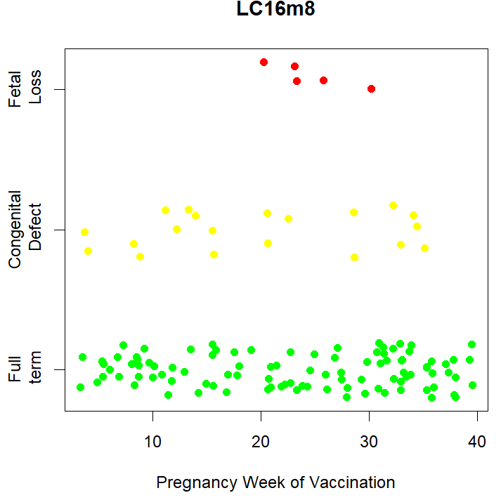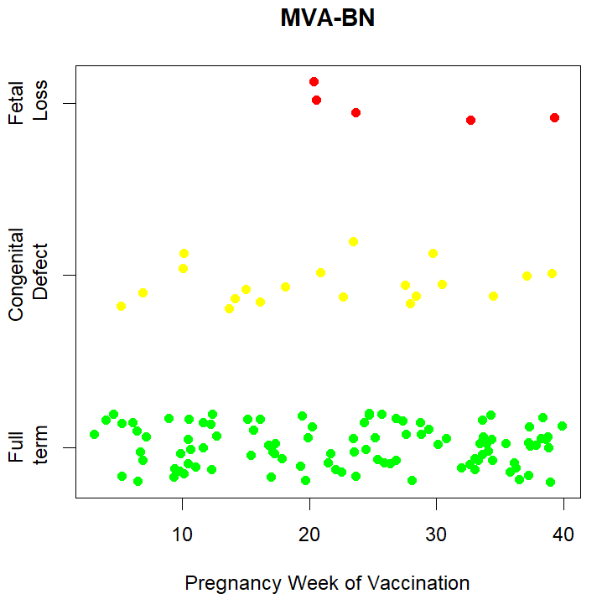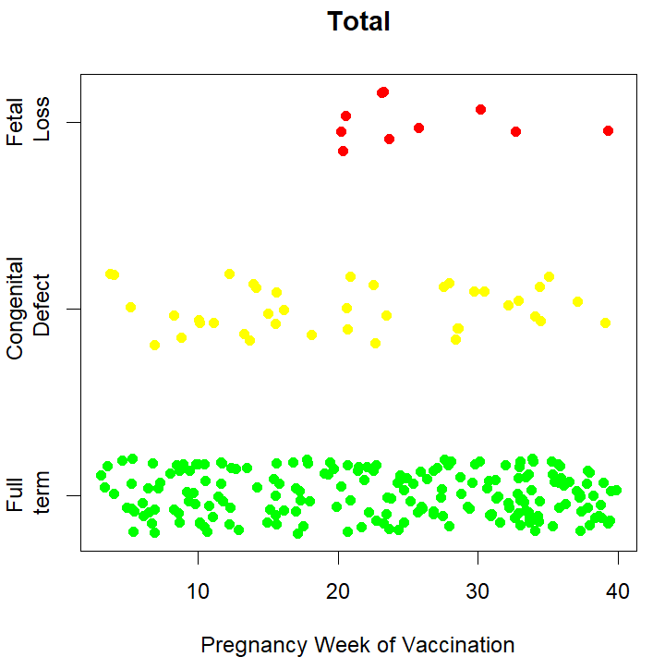

- Listing of congenital defects, with week of vaccination in pregnancy.

Table 16: Listing of congenital defects, with week of vaccination in pregnancy.
Date of vaccination | Last menstrual period (LMP) | Date of birth | Narrative of pregnancy outcome

If sufficient cases exist, logistic regression where an indicator of congenital defect is the outcome variable and type of vaccine is a predictor, with major risk factors for congenital defects are included in the model. These factors should include maternal age, family history of congenital defects, and known maternal comorbidities.

Table 17. Frequency of SAEs and AESIs by Age Group and Sex.
Age group | Sex | N | SAEs (n, %) | AESIs (n, %)
<18 | Male
<18 | Female
18–30 | Male
18–30 | Female
30 to <50 years | Male
30 to <50 years | Female
50 to <65 years | Male
50 to <65 years | Female
65+ years | Male
65+ years | Female

Table 18. SAEs and AESIs by Week Since Vaccination.
Week postvaccination | N Observed | SAEs (n, %) | AESIs (n, %) | 95% CI (AESIs)
Week 1
Week 2
Week 3
Week 4

Comparison to Expected / Background Rates:
For SAEs and for AESIs with available background rates appropriate to the region, observed-to-expected analyses will be performed. The observed incidences for AESIs and SAEs will be compared with expected incidences obtained from the most appropriate sources (e.g., clinical trials, epidemiological studies including Global Vaccine Data Network (GVDN) where appropriate). Where data permit, expected rates will be stratified by age, and standardized incidence ratios (SIRs) will be calculated to assess relative risk. If appropriate background rates are not available for key outcomes, self-controlled risk interval (SCRI) design will be considered as an exploratory analysis.

Table 19. Observed vs Expected Incidences for AESIs and SAEs.
Condition | Age group | Observed incidence  (/1,000) | Expected incidence*  (/1,000) | Standardized incidence ratio (SIR) | 95%  CI
AESI1 (N=)
AESI2 (N=)
* Include footnote that cites sources for background rates

- For reactogenicity, the proportion of individuals with at least one solicited AE will be calculated overall, by event type and severity and by time since vaccination, in days. For proportions, 95% confidence intervals will be calculated using an exact method. For each type of reactogenic event and severity, the duration (in days) with their mean/median and standard deviation/range will be calculated. Observed-to-expected analyses will be performed.
- Statistics will also be generated for any adverse event following immunization, regardless of the severity.

Table 20. Reactogenicity by Event Type and Severity.
Event type | Severity | N with event | % (of Total) | 95% CI | Mean  duration  (Days) | Median (Range)
Fever | Grade 1
Fever | Grade 2
Event type | Severity | N with event | % (of Total) | 95% CI | Mean  duration  (Days) | Median (Range)
 | Grade 3
Pain | Grade 1
Pain | Grade 2
Pain | Grade 3

